--1) Total revenue
select SUM(total_price)AS TOTAL_REVENUE from pizza_sale
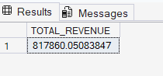
--2) Average order value
SELECT SUM(total_price) / Count(Distinct order_id) AS Avg_order_value from pizza_sale
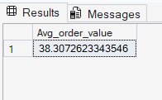

--3)Total Pizza Sold
Select sum(quantity) As total_Pizza_Sold from Pizza_sale
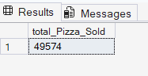

--4)Total orders
Select Count(Distinct order_id) As Total_Orders From Pizza_sale
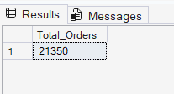

--5)Average Pizzas Per Order
Select CAST( CAST(SUM(quantity) AS DECIMAL(10,2)) /
CAST(count(Distinct order_id) AS DECIMAL(10,2))AS DECIMAL(10,2)) AS avg_pizza_perorder from pizza_sale
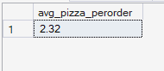

--6)Daily Trend For Total orders
Select DateName(DW,order_date) as order_day, Count(Distinct order_id) AS Total_orders From pizza_sale
GROUP BY DATENAME(DW, Order_date)
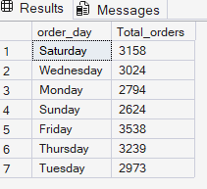

--7)Monthly trend for Orders
SELECT DATENAME(MONTH, order_date) AS Month_Name,count(Distinct order_id) As Total_orders from pizza_sale
GROUP BY DATENAME(Month, Order_date)
ORDER BY Total_orders DESC
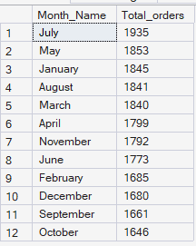

--8)% percentage of sales by pizza category
SELECT pizza_category,sum(total_price) as Total_sales, sum(total_price) * 100 / (SELECT SUM(total_price) from pizza_sale)AS PERCENTAGE_OF_SALES from pizza_sale
group by pizza_category
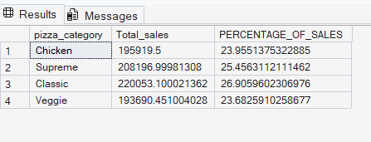

--9)% percentage of sales by pizza size
SELECT pizza_size,CAST(sum(total_price) AS DECIMAL(10,2)) as Total_sales,CAST(sum(total_price) * 100 / (SELECT SUM(total_price) from pizza_sale WHERE DATEPART(QUARTER,order_date)=1 )AS Decimal(10,2)) AS PERCENTAGE_OF_SALES from pizza_sale
WHERE DATEPART(QUARTER,order_date)=1
group by pizza_size
Order by PERCENTAGE_OF_SALES DESC

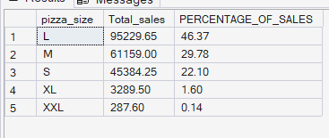

--10. Total Pizzas Sold by Pizza Category
SELECT pizza_category, SUM(quantity) as Total_Quantity_Sold
FROM pizza_sale
WHERE MONTH(order_date) = 2
GROUP BY pizza_category
ORDER BY Total_Quantity_Sold DESC
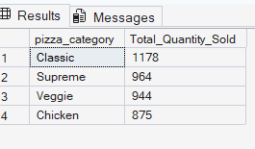

-- 11.Top 5 Pizza Sold
SELECT TOP 5 pizza_name,Count(Distinct order_id) AS Total_Orders from pizza_sale
group by pizza_name
order by Total_Orders Desc
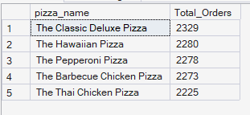

-- 12. BOTTOM 5 PIZZA SOLD
SELECT Top 5 pizza_name, SUM(total_price) AS Total_Revenue
FROM pizza_sale
GROUP BY pizza_name
ORDER BY Total_Revenue ASC

